2026 Internship (Paid)
Bighorn Canyon National Recreation Area - National Park Service
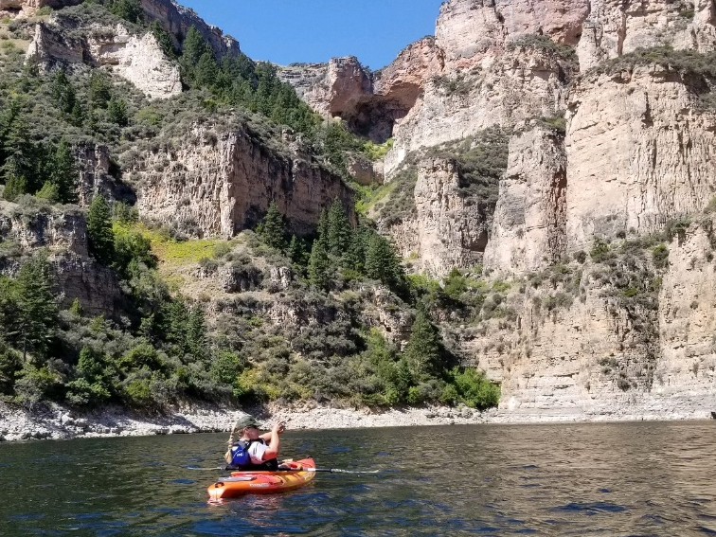
This is a paid internship position(s) through MSU’s Institute on Ecosystems. ($16/hour)

Position Description: Interns will work alongside Bighorn Canyon and Wyoming Game and Fish staff as part of the larger Aquatic Invasive Species (AIS) program.

Overview: 70% of the intern’s time will be focused on AIS monitoring and education. This will include monitoring and collecting eDNA results, becoming AIS inspector certified, conducting boat inspections, and educating the public about the importance of keeping AIS out of our waters. 20% of the time will be programming and NPS orientation, including guided hikes, kayak programs, site tours, and visitor center desk. The final 10% of this program, provides opportunity for the intern to work with different work groups within the park as well as outside recreation partners.

Work Details:
- The job is 5 days a week, 8 hours a day work schedule including weekends and holidays.
- Some work will be indoors, most of the work will be completed outside. Temperatures can range from 50 to 70 degree days to over 100 degrees.
- The intern will be expected to collect data following established protocols and complete AIS boat inspections.

Requirements:
- Physical ability to conduct Kayak programs, and guided hikes.
- Attend orientation training and safety training prior to entering the field.
- The intern should anticipate working from mid-May through mid to late August in desert weather conditions and in the presence of insects and wildlife.
- NPS will provide opportunities to take CPR and First Aid courses
- The intern is expected to be inquisitive and engaged through hands-on and active participation in fieldwork, planning and logistics, proactive in learning new skills, and supportive of other crew members.
- Interns are expected to conduct themselves professionally as a representative of the National Park Service.
- A full commitment and scheduling flexibility is required.

Logistics:
- Housing will be provided

Contact information: Interested applicants should send a letter of interest, resume, and contact information for three references by 2/13/2026 to: Christy_fleming@nps.gov. Resumes received after that time will be reviewed on an as-needed basis. Please contact Christy with any questions.

